**THE UNIVERSITY OF DODOMA**

**THE COLLEGE OF INFORMATICS AND VIRTUAL EDUCATION**



**DEPARTMENT OF COMPUTER SCIENCE AND ENGINEERING**

INDUSTRIAL TRAINING ONE REPORT

**At the College of Informatics and Virtual Education**

Morning Technology: Java Programming

Project title: Library Management System

**By**

|  |  |  |  |  |
| --- | --- | --- | --- | --- |
| **S/N** | **STUDENT NAMES** | **REG NO.** | **DEGREE PROGRAM** | **SIGNATURE** |
| 1. | FALAJI A. MBILINYI | T/UDOM/2020/07107 | Bsc. SE |  |
| 2. | HLESTACOV KIGODA WANDIBA | T/UDOM/2020/00371 | Bsc. SE |  |
| 3. | SALOME ELIAS | T/UDOM/2020/ 00381 | Bsc. SE |  |
| 4. | ANUARI I. ISSA | T/UDOM/2020/00345 | Bsc. SE |  |

**Submitted to:**

DR. NOE ELISA

Prof. Leonard Mselle

The Principle Of CIVE

2020/2021

**TABLE CONTENTS**

LIST OF FIGURES iii

LIST OF TABLES iii

ABSTRACT: v

ACKNOWLEDGEMENT vi

CHAPTER 1 1

**1.** **INTRODUCTION** 1

**1.1 OVERVIEW** 1

1.1.1 PROBLEM STATEMENT 1

1.2 JUSTIFICATION 2

**1.3. OBJECTIVES** 2

1.3.1. GENERAL OBJECTIVES 2

1.3.2 SPECIFIC OBJECTIVES 2

**1.4 SCOPE OF THE PROJECT** 2

CHAPTER 2 3

**2.1 LITERATURE SURVEY:** 3

CHAPTER 3 4

**3.1 METHODOLOGY** 4

**3.2 REQUIREMENT ANALYSIS AND DESIGN** 4

CHAPTER 4 6

**4.1 WORK DONE** 6

CHAPTER 5 10

TIME SCALE AND RESOURCES 10

**5.1 TIME SCALE** 10

**5.2 RESOURCES** 11

CHAPTER 6 12

**6.1 CONCLUSION & FUTURE SCOPE** 12

CHAPTER 7 13

**7.1 REFERENCES** 13

# **LIST OF FIGURES**

**Figure 1.Login admin page** 6

**Figure 2.Dashboard of System** 7

**Figure 3.Add Student** 7

**Figure 4.Student Search** 8

**Figure 5.Student Issues Book** 8

**Figure 6.Add Book** 9

**Figure 7.Book Search** 9

**Figure 8.Database of project** 10

# **LIST OF TABLES**

**Table 1. Display time taken to accomplish project** 10

**Table 2. Resource used and cost** 11

**ACRONYMS AND ABBREVIATIONS**

* XAMPP-My stands for the co-founder Michael Wideness’s daughter and SQL stands for Structured Query Language
* WAMP: Window /Apache/MySQL and Perl

# **ABSTRACT**

*Online Library Management System* is a system which maintains the information about the books present in the library, their authors, the members of library to whom books are issued, library staff and all. This is very difficult to organize manually. Maintenance of all this information manually is a very complex task. Owing to the advancement of technology, organization of an Online Library becomes much simple. The Online Library Management has been designed to computerize and automate the operations performed over the information about the members, book issues and returns and all other operations. This computerization of library helps in many instances of its maintenances. It reduces the workload of management as most of the manual work done is reduced.

­­

# **ACKNOWLEDGEMENT**

We are grateful to God with his gift of his grace, we can complete this project of Library Management System using java programming successfully without any problem. We also wish to express our appreciation and gratitude to our supervisors of this project, Pro.Leonard Msele &Dr. Noe Elisa and their supporting supervisors Tsokyo Mriwa & Victor Eliote Malenga for their guidance, motivation, knowledge, patience and encouragement given during the period of field and project implementation. We also wish to express our appreciation to our coordinator Bigten Kikoba for their advice and guidance throughout the field period.

Our sincere thanks also go to our friends for their continuing support and encouragement all the way to accomplish our project especially our classmates in Java Programing who always give moral support when we were discouraged. We are grateful to our beloved families for their encouragement, and their support throughout the field period. Thank you.

# **CHAPTER 1**

## **INTRODUCTION**

**Library Management System (LMS)** is a computerized system which helps user(librarian) to manage the library daily activity in electronic format. It reduces the risk of paper work such as file lost, file damaged and time consuming. It can help user to manage the transaction or record more effectively and timesaving.

## **1.1 OVERVIEW**

### **1.1.1 PROBLEM STATEMENT**

Library Management System is among the online system which deal with the different problem occur in the library service.

Therefore, the problem occurred before having computerized system includes:

• **File lost**

When computerized system is not implemented file is always lost because of human environment. Sometimes due to some human error there may be a loss of records.

• **File damaged**

When a computerized system is not there, file is always lost due to some accident like spilling of water by some member on file accidentally. Besides some natural disaster like floods or fires may also damage the files.

• **Difficult to search record**

When there is no computerized system there is always a difficulty in searching of records if the records are large in number.

• **Space consuming**

After the number of records become large the space for physical storage of file and records also increases if no computerized system is implemented.

• **Cost consuming**

As there is no computerized system the to add each record paper will be needed which will increase the cost for the management of library.

### **1.2 JUSTIFICATION**

To address this problem, we are developing library management system which help librarian manage the record of book and users details information more effectively and timesaving. So, the system will simply distribution compare to previous system

## **1.3. OBJECTIVES**

### **1.3.1. GENERAL OBJECTIVES**

The main objective of this project is to develop online library management system Improvement in control and performance of library service. The system is developed to cope up with the current issues and problems of library.

### **1.3.2 SPECIFIC OBJECTIVES**

1. To gather the requirement of the system
2. To design the architecture of the system
3. To implement the requirements of the system
4. To evaluate the requirement of our system
5. To Save cost After computerized system is implemented less human force will be required to maintain the library thus reducing the overall cost.
6. To Save time Librarian is able to search record by using few clicks of mouse and few search keywords thus saving his valuable time compared to old system.

## **1.4 SCOPE OF THE PROJECT**

Library Management System is an online system which involves two users which are student and librarian. Librarian will enable adding a student as the member, search registered student. And search all detail deal with book include issue book, available book. These will improve the efficient of library service to the community where it will solve time consuming, save cost.

# **CHAPTER 2**

## **2.1 LITERATURE SURVEY:**

Library Management System is an application which refers to library systems which are generally small or medium in size. It is used by librarian to manage the library using a computerized system where he/she can add new books students and Page sources. Books and student maintenance modules are also included in this system which would keep track of the students using the library and also a detailed description about the books a library contains. With this computerized system there will be no loss of book record or member record which generally happens when a non-computerized system is used. All these modules are able to help librarian to manage the library with more convenience and in a more efficient way as compared to library systems which are not computerized.

# **CHAPTER 3**

## **3.1 METHODOLOGY**

A methodology is a standard process followed in organization to conduct all the steps necessary to analyze design, implement and maintain information, it involves series of step to accomplish the project which are

**3.1.1 Data collection methods;** We used three methods in data collection; interview, literature review and observation

**Observation.** we observed the current operation in our college library where there is use of paper work system where by the librarian collect all detail of student.

**3.1.2 System designing;** Our system development used **agile methodology**, because agile is characterized by short interactive cycle, extensive testing, active involvement of users for establishing, periodizing, verifying requirement and focus on small teams of talented (experienced) programmer

As the agile methodology priotizes the customer involvement it provided close involvement in each increment, and also our system relied on agile method to maintain the simplicity of the software development which made it different from other methodology such as spiral model, prototype and waterfall model

## **3.2 REQUIREMENT ANALYSIS AND DESIGN**

The system will clearly describe what the project will deliver and that outline generally at all levels work required to complete the project.it divided into two function requirements and nonfunctional requirements

**FUNCTION REQUIREMENTS**

**3.2.1 Librarian**

1. The system should allow user to login
2. The system should allow user to add new student
3. The system should allow user to view book details
4. The system should allow user search book
5. The system should allow user to view issue book
6. The system should allow the user logout
   * 1. **Student**
7. The system should allow user to registration
8. The system should allow user to login
9. The system should allow user to see all information book
10. The system should allow the user to issues book
11. The system should allow user to logout

**NON-FUNCTION REQUIREMENTS**

1. The system should be able to recover fast when its down
2. The system should be maintainable i.e., even when a problem occur will be easy to repair
3. The system should secure the user information i.e., by encrypting the user passwords.
4. The system should be reliable to operate without any failure
5. The system should operate with appropriate speed
6. The system should be user friendly whereby all user will be able to understand different things and easy to use

# **CHAPTER 4**

## **4.1 WORK DONE**

**Login Admin**

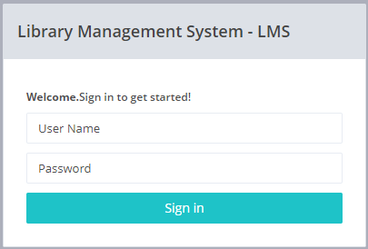

**Figure 1.Login admin page**

This page give access to admin authentication by give verification of username and password.

**Dashboard**

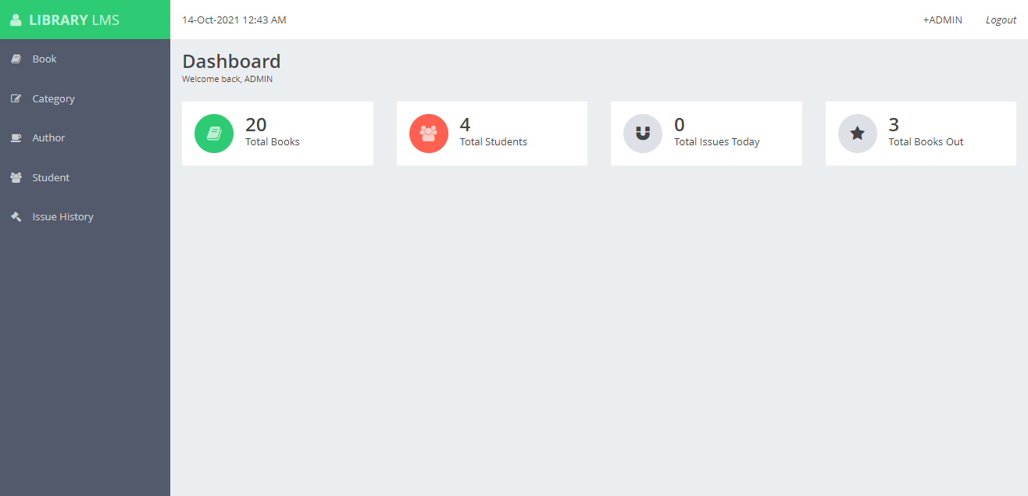

**Figure 2.Dashboard of System**

This page shows mainly admin home page after successful login, contains different attributes which allows content to be displayed according to the needs of the administrator

**Student**

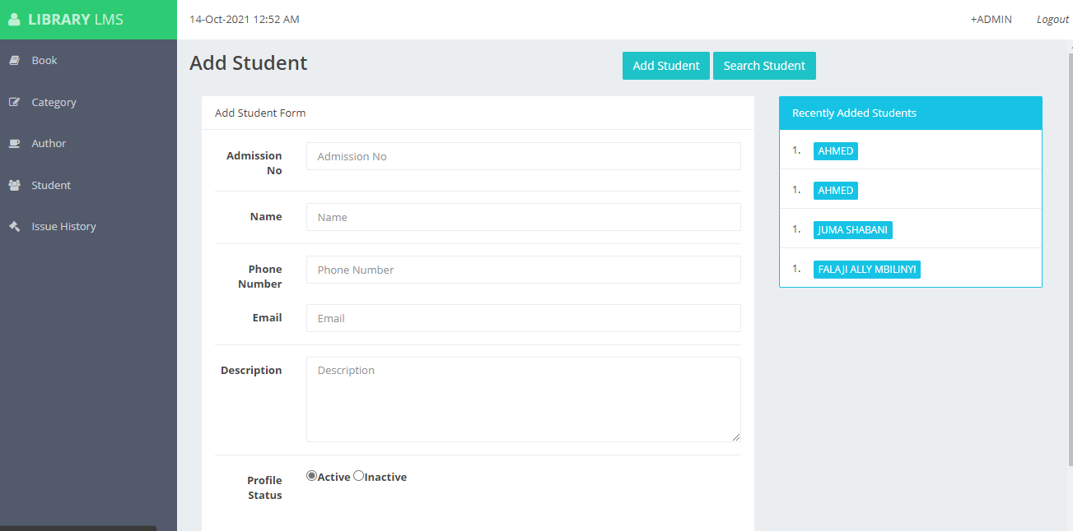

**Figure 3.Add Student**

This page contains Student Registration panel which give access to the administrator to add student to be member of the library system

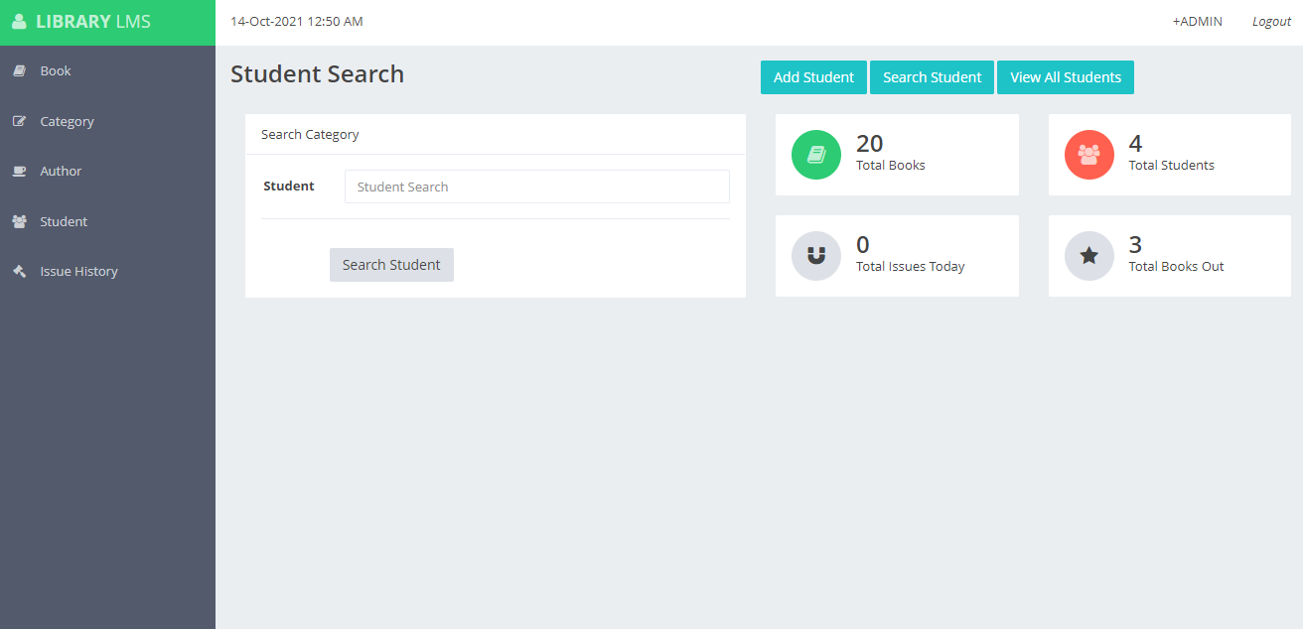

**Figure 4.Student Search**

**This page allows administrator the search for the existing student whose already registered as the member.**

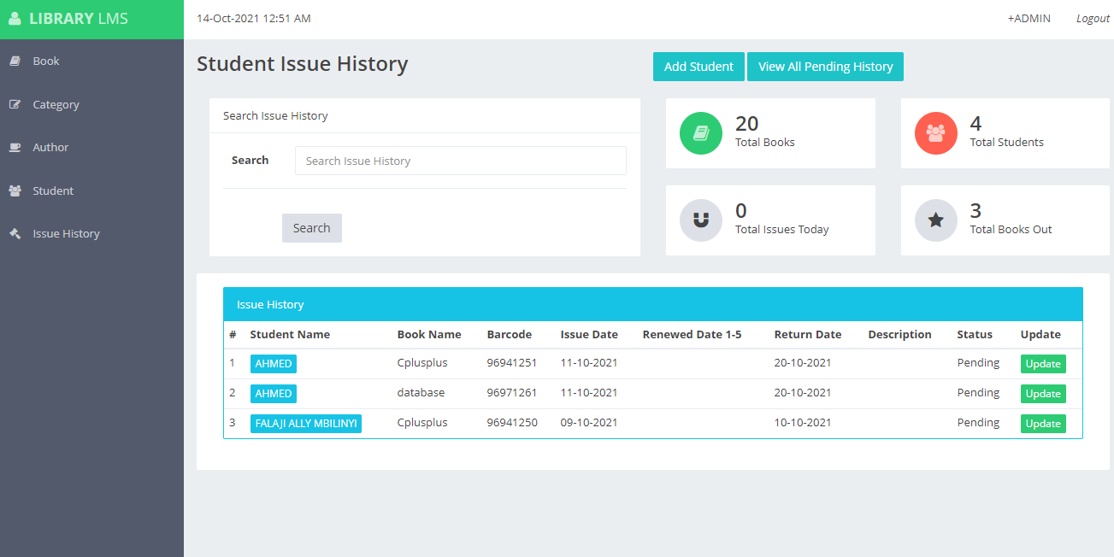

**Figure 5.Student Issues Book**

This page describe the student history whose already issued book, this display all record of the issued book and student who issue that book.

**Book**

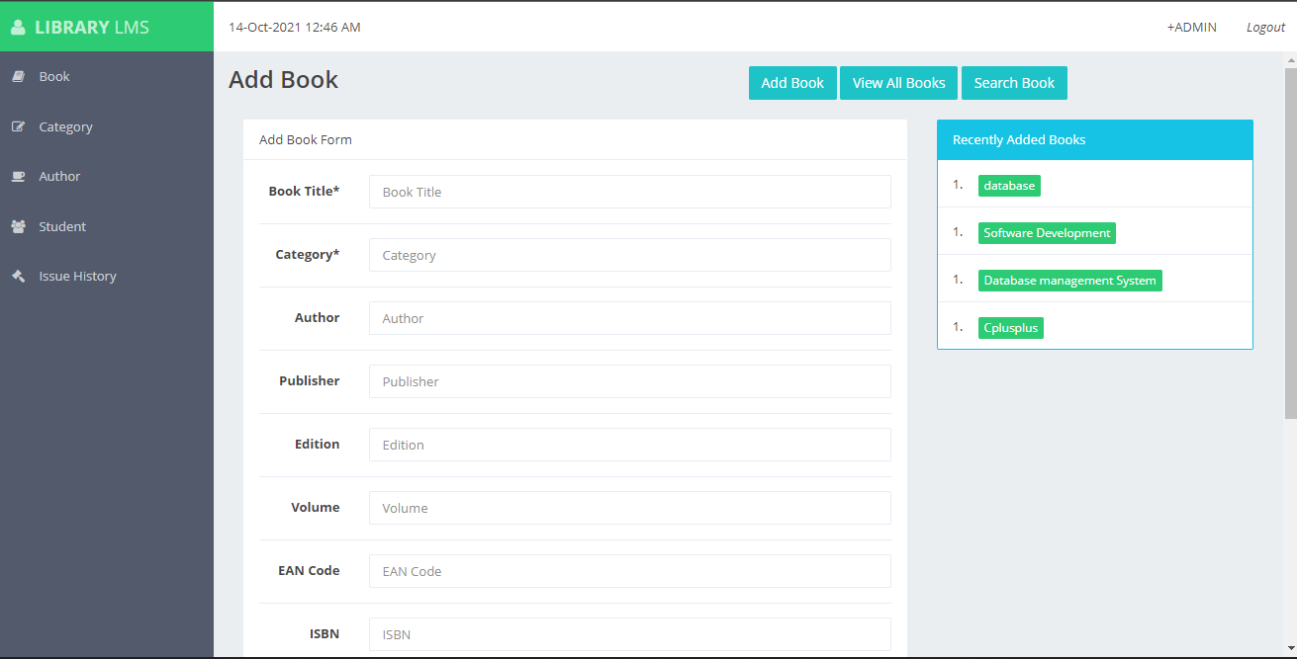

**Figure 6.Add Book**

This page allows admin to add new book so as to be displayed on the system to enable student to issue it as well.

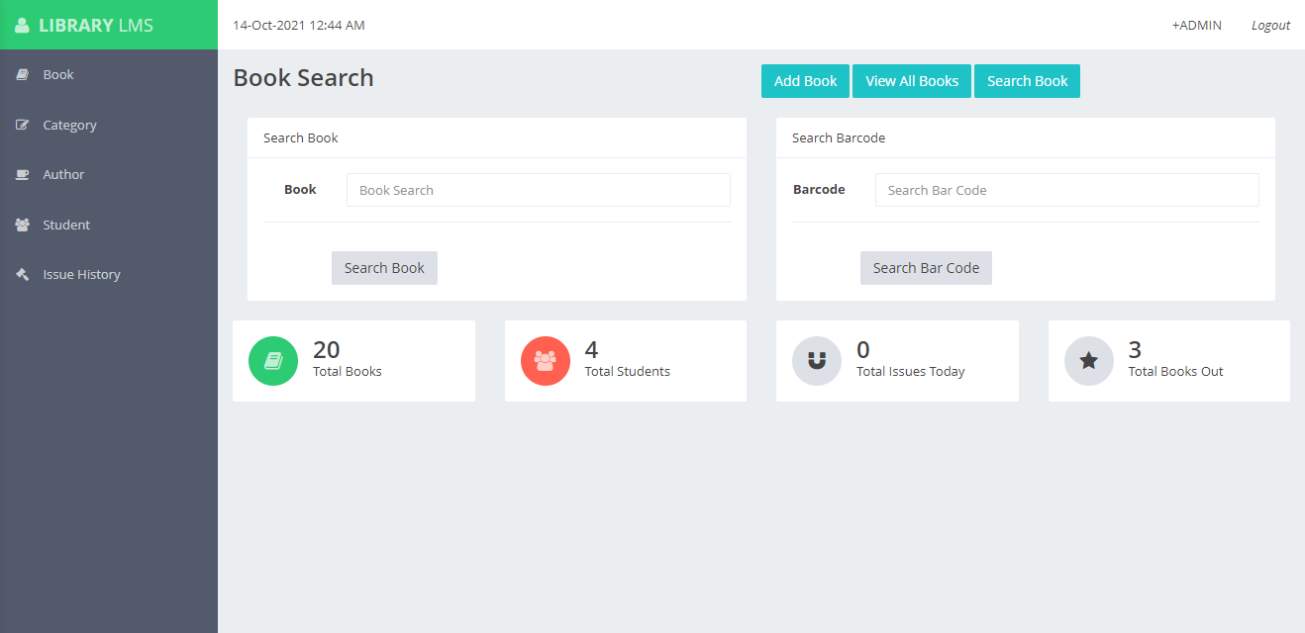

**Figure 7.Book Search**

This page describe the searching panel to all registered books, administrator can be able to view all added books

**Database**

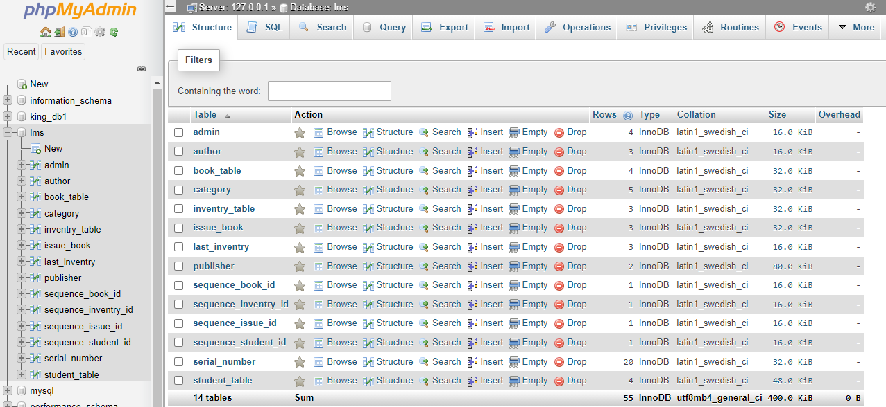

**Figure 8.Database of project**

**This figure shows all of the project database details, all of the tables and their description**

# **CHAPTER 5**

# **TIME SCALE AND RESOURCES**

## **5.1 TIME SCALE**

The time scale of project will take maximum time of one months.

SUMMARY TABLE

**Table 1. Display time taken to accomplish project**

|  |  |  |
| --- | --- | --- |
| S/N | ACTIVITY | TIME USED |
| 1. | Proposal development | 2 days |
| 2. | Requirement gathering | 2 days |
| 3. | Requirement analysis | 3 days |
| 4. | System design | 1 week |
| 5. | System coding | 1 week |
| 6. | Testing | 6 days |
| 7. | Presentation of the system | 1 day |

## **5.2 RESOURCES**

The budget of our project it includes different software and hardware excluding with the texting budget, the total cost is seven hundred thousand used in accomplishing the project

**Table 2. Resource used and cost**

|  |  |
| --- | --- |
| **Items** | **Cost** |
| Hard disk | 100,000 |
| Computer | 500,000 |
| Sublime text, xampp | Free |
| NetBeans | Free |
| **Total** | **600,000** |

# **CHAPTER 6**

## **6.1 CONCLUSION & FUTURE SCOPE**

At the end of the project, the system is expected to provide the following outputs(goals) and benefits. Firstly, will ensure the website system provides a computerized version of library management system which will benefit the students as well as the staff of the library.

It makes entire process online where student can search books, it also has a facility for student login where student can login and can see status of books issued as well request for book or give some suggestions.

There is a future scope of this facility that many more features such as online lectures video tutorials can be added by teachers as well as online assignments submission facility, a feature of group chat where students can discuss various issues of engineering can be added to this project thus making it more interactive more user friendly and project which fulfills each user need in the best way possible.

So, this project will increase the efficiency in the library services, also It reduces cost and save time compare to the previous library method.

**LIMITATIONS**

* Time limiting, for the project.
* Lack of efficiency resource of project such as powerfully computer

# **CHAPTER 7**

## **7.1 REFERENCES**

1. Open Library Management System, *John Little (Duke University)*
2. <http://www.e-framework.org>
3. <http://www.w3schools.com>
4. <http://www.Udemy.com>
5. <http://www.tutorialpoints.com>